Launching a Virtual Server on AWS EC2

Introduction to Amazon EC2
Amazon EC2 (Elastic Compute Cloud) is a cloud computing service provided by Amazon Web Services (AWS). It allows users to create and use virtual servers (called EC2 instances) in the cloud.
Step 1: Sign in to AWS Console
AWS Console is the web interface through which you can access AWS services such as EC2, S3, RDS, and Lambda.
Step 2: Open the EC2 Dashboard
The EC2 Dashboard is the main page where you can create and manage your EC2 virtual servers.
Screenshot
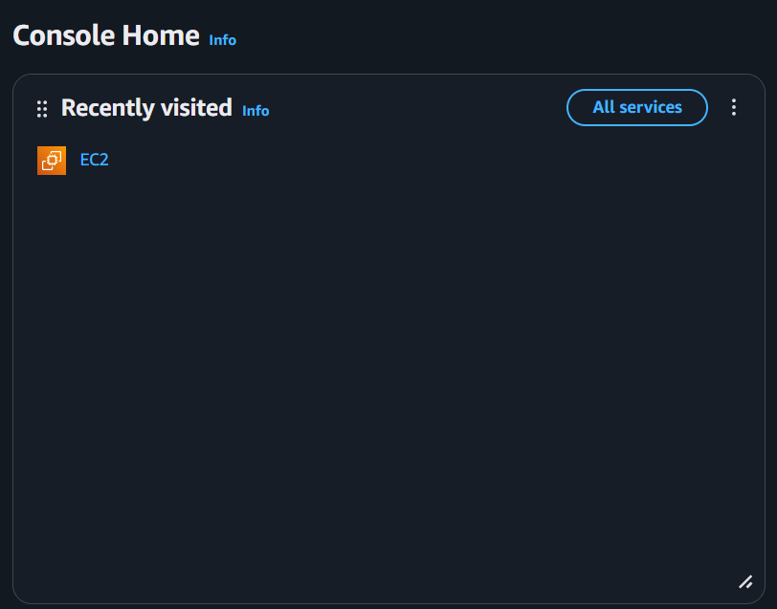

Step 3: Launch an EC2 Instance
In this step, we will create a virtual server in AWS. This virtual server is called an EC2 Instance.
Screenshot
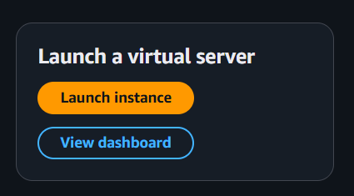

Step 4: Name the Server and Choose OS
Named the instance and selected Operating System (Free Tier Eligible).
Screenshot
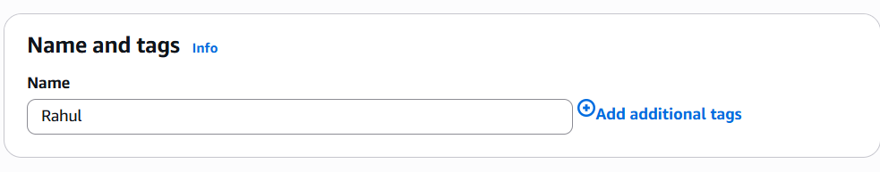
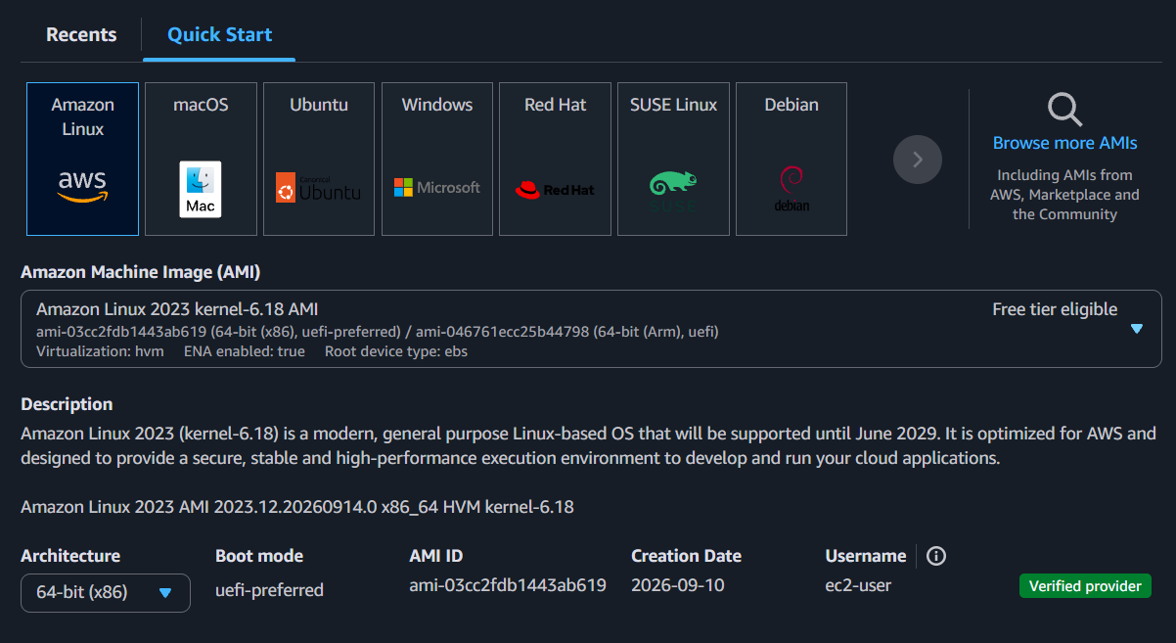

Step 5: Select Instance Type
Instance Type decides how much CPU, RAM, and computing power your EC2 server will have.
Screenshot
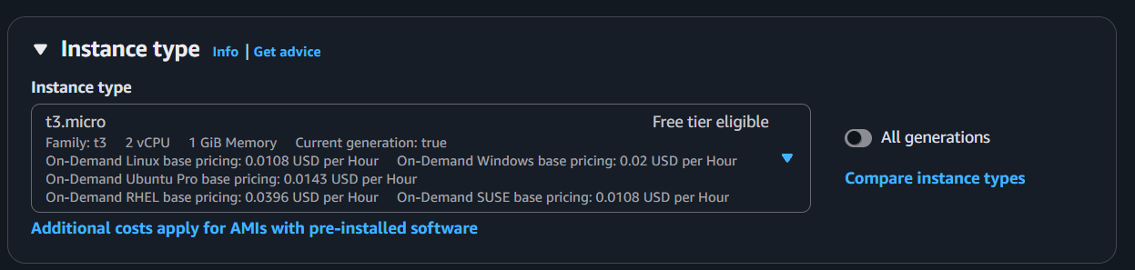

Step 6: Create and Download Key Pair
A Key Pair is used to securely connect to your EC2 server. It contains two keys:
- Public Key → Stored on the EC2 server.
- Private Key → Downloaded and kept by you.
Screenshot
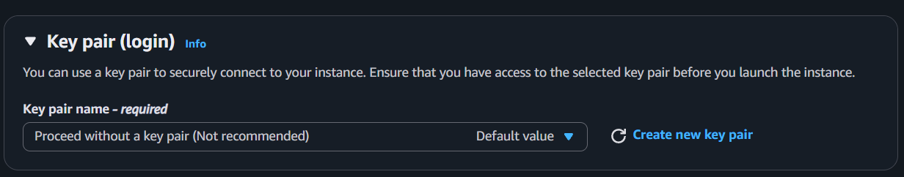

Step 7: Configure Network Security
Network Security controls who can connect to your EC2 server and which types of connections are allowed.
Screenshot
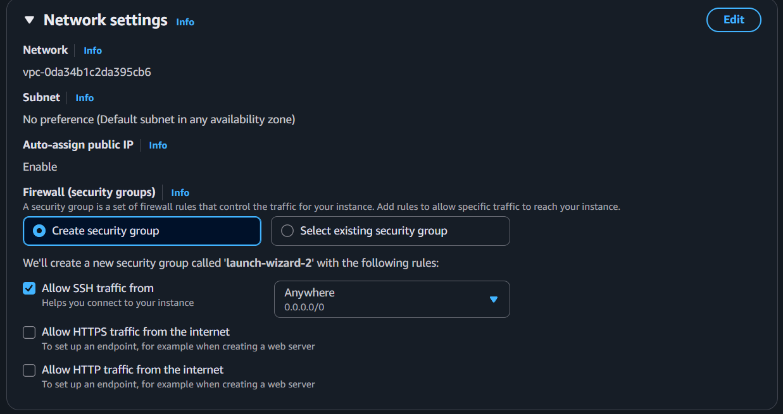

Step 8: Configure Storage
In this step, we assign the default 8 GiB SSD root volume, which provides persistent block-level disk storage (EBS) to keep the operating system and saved files permanently intact.

Screenshot
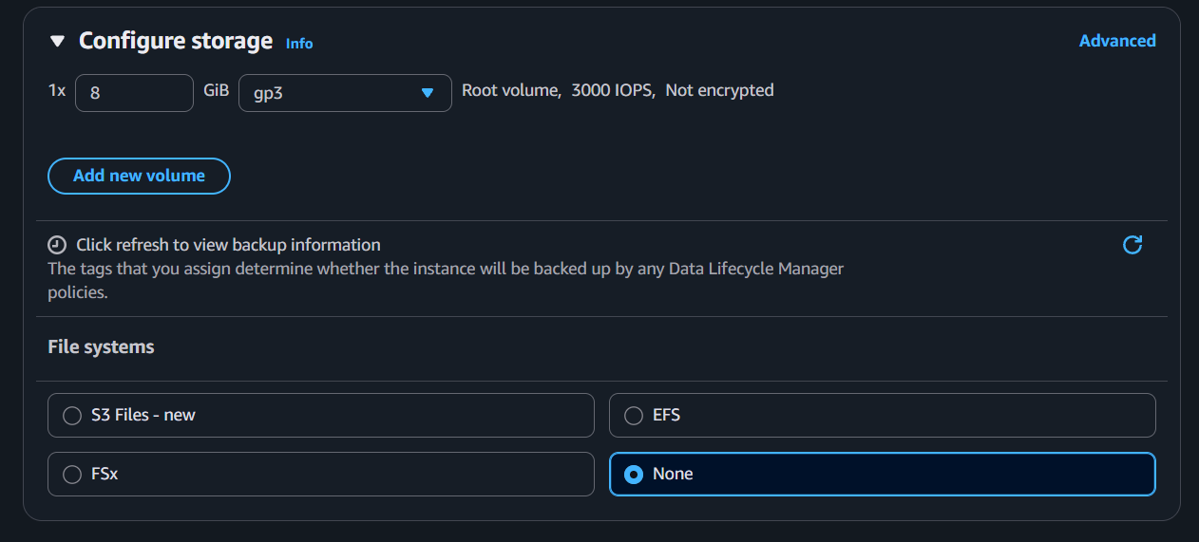

Step 9: Launch the Server
In this step, we review our setup and click the launch button, which submits our request to AWS to automatically allocate physical hardware, attach storage, and boot the virtual server.

y
Screenshot
